SCUBA-2 Block Specification
cmd_queue

Created on: 7 October 2005
Last saved on: 07 October 2005
Table of Contents

1. Block Description 3
1.1 Block Hierarchy 3
1.2 Block Overview and Features 3
1.3 Detailed Description 3
2. Interface Description 5
2.1 Signals Description 5
2.2 Protocol / Interface Timing 5
3. Dataflow Description 6
4. State Machine Description 7
4.1 FSM 1 7
4.2 FSM 2 7
Files Associated with this Block 8

Block Description

Block Hierarchy

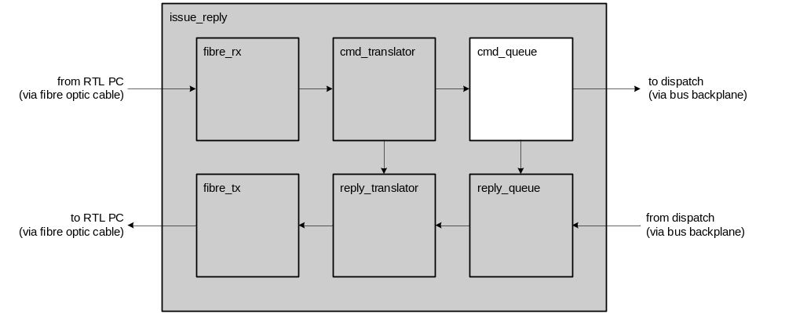

Block Overview and Features
This main functions of this block are to:
- Parse macro-ops received from the cmd_translator
- Generate micro-ops based on the macro-ops received, and insert them in the micro-op queue.
- Send micro-ops across the bus backplane at their scheduled times.
- Retire micro-ops that have sent by removing them from the micro-op queue.

Macro-ops are generated by the cmd_translator and passed on to the cmd_queue. Macro-ops are generated either by receiving a command from Realtime Linux computers, or by an internal FSM that monitors the status of the electronics and can power down if necessary. Both of these types of commands are tagged differently, but are processed in an identical fashion by the cmd_queue.
The cmd_queue acts as a micro-op generator for macro-ops passed on to it from the cmd_translator. It treats certain macro-ops differently based on their parameter-id. For example, get_status or get_data macro-ops generate several micro-ops in response (these are the only two that are treated specially). Each of the micro-ops generated serve to accomplish the overall task that was requested by the macro-op.
Other than the two aforementioned macro-ops, all other micro-ops are treated the same and generate only one micro-op. Generally speaking, the cmd_queue acts as a command traffic manager.

Detailed Description
In addition to a command-queue (which acts a central repository for micro-ops as they are executed in the system) there are four FSMs that exist in the cmd_queue block:
- Generate:
The Generate FSM receives macro-ops from the cmd_translator. It will remain idle until it detects that a macro-op is available from the cmd_translator (cmd_translator asserts macro_instr_rdy_o). The Generate FSM will then notify the Insert FSM that a macro-op is ready to be inserted if there is space in the queue.

- Insert:
The Insert FSM adds micro-ops to the cmd_queue when it is notified to by the Generate FSM. The Insert FSM assembles header-data received from the cmd_translator in two 32-bit words in a format outlined in BBInstructions.xls. Following the insertion of the two header-words, the Insert FSM will assert the mop_ack_o signal to the fibre_rx to acknowledge that the header information for the micro-op has been inserted. Following this, if there is data to be inserted with the micro-op, the fibre_rx block will begin clocking data through to the Insert FSM which is inserted in the cmd_queue following the two header words. The micro-op is then complete, and ready to be issued during the appropriate sync-pulse.

- Send
The Send FSM transmits micro-ops from the cmd_queue over the bus backplane via the lvds_tx block. It waits until the appropriate sync pulse to issue each command, based on the send-sync-pulse value that is embedded in the two header-words at the beginning of each micro-op in the cmd_queue. If the Send FSM deems that the micro-op that it is to send has expired, then it discards that micro-op. As the words of the micro-op are clocked out of the cmd_queue to the lvds_tx block, each word is also used to generate the micro-op’s checksum. After the command has been completely transmitted, the checksum is also complete, and is sent out immediately after the micro-op.

The checksum is generated by the Send FSM rather than the Insert FSM because it takes the lvds_tx some time to clock each of the micro-op’s 32-bit-words out over the bus backplane – enough time to allow the checksum generator to parse a word and return to idle before lvds_tx has finished. If the Insert FSM generated the checksum, its generation would be the speed-limiting step, because the checksum is generated serially but the Insert FSM appends words in parallel to the cmd_queue. Thus, the Insert FSM is much faster than the checksum generator, but the Send FSM is not.

- Retire
The Retire FSM waits to receive notification from the reply_queue that a micro-op has finished executing, and can be removed from the cmd_queue. The Retire FSM need not be notified whether a micro-op has executed successfully in the MCE or not, because it will generally be too late to issue a duplicate micro-op to recover from the error. The timing between sync pulses is prohibitively short.

The reply_queue will receive responses to micro-ops from the lvds_rx modules. As the reply_queue does its business, the cmd_queue will put valid data on its uop_o line, and assert the uop_rdy_o signal to indicate the next micro-op to retire. As responses are received, the reply_queue will compile the data for the micro-op assembled into a format understood by the reply_translator. Once a reply packet has been amalgamated, the reply queue will assert its uop_ack signal to the cmd_queue indicating that a single data packet has been assembled, and that the micro-op that generated that response can now be retired from the cmd_queue. The cmd_queue then will retire the micro-op and de-assert the uop_rdy_o line for at least one clock cycle. Once the uop_rdy_o line has been de-asserted, the reply_queue is then free to release the response to the reply_translator for transmission through fibre_tx.

Interface Description

Signals Description
Signal | Description | Direction
Global Signals
sync_i | Delimits the frames periods | in
sync_num_i | Determines when and when not to issue micro-ops | in
clk_i | Global clock signal (50 MHz) | in
rst_i | Global asynchronous active-high reset | in
Signals to/from lvds_tx
tx_o | Serial LVDS output line from the lvds transmitter | out
clk_200mhz_i | Serial LVDS block fast clock | In
Signals to/from cmd_translator
card_addr_i | The card address of the macro-op | in
par_id_i | The parameter id of the macro-op | in
data_size_i | The number of 32-bit words of data in the macro-op | in
data_i | Data belonging to a macro-op | in
data_clk_i | The data clock that fibre_rx uses to clock data into the cmd_queue. There are restrictions on how fast the data clock can be to allow the cmd_queue to store each 32-bit word of data. | in
mop_i | Macro-op sequence number | in
issue_sync_i | The issuing sync-pulse sequence number | in
mop_rdy_i | Tells cmd_queue when a macro-op is ready | in
mop_ack_o | Tells the cmd_translator when cmd_queue has taken the macro-op and is ready to receive data | out
Signals to/from
reply_queue
uop_rdy_o | Tells the reply_queue when a valid micro-op code is asserted on it's interface | out
uop_ack_i | Tells the cmd_queue that a reply waiting to be retired has been found and it's status is asserted on uop_status_i and it’s header is asserted on uop_header_i. | in
uop_o | Tells the reply_queue the next u-op that the cmd_queue wants to retire | in

Protocol / Interface Timing
[insert timing diagrams here]

Dataflow Description

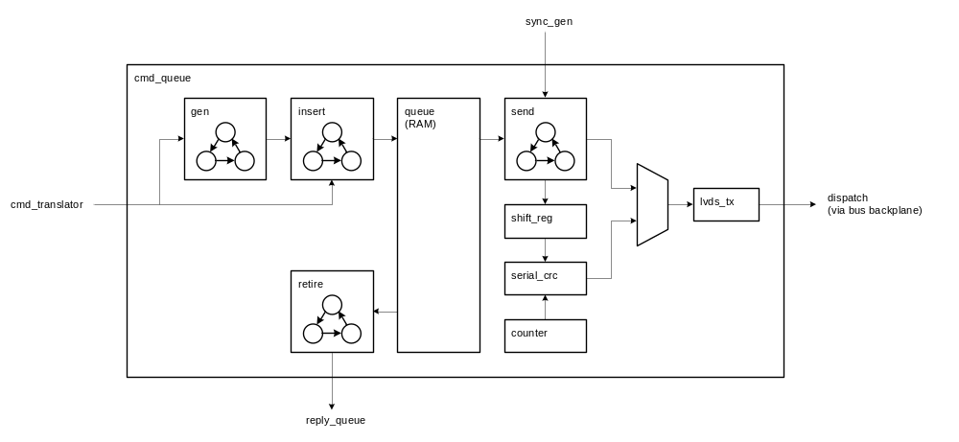

State Machine Description

FSM 1
[insert ASM chart here]

FSM 2
[insert ASM chart here]

Files Associated with this Block

File | Description
[list all files that belong to this module] | [and enter a short description beside each]

